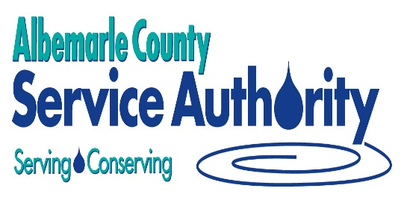

October 16, 2017

Re: Water Conservation Tips

Dear Business Customer:

As you may already know, a Drought Warning requiring Mandatory Water Restrictions has been issued for the Charlottesville and Albemarle County region. Water is a precious resource at any time. But, in the middle of a drought, water conservation becomes particularly important. A water shortage affects everyone and we are asking all our customers to help conserve our precious water any way you can. Every drop counts! Please encourage your family, friends and neighbors to follow your lead in conserving water.
Included with this letter are water conservation tips on how your business can reduce its water use. The hope is that we can decrease the system demand for water and give our water supply time to replenish as rain falls over the next few months.

Albemarle County Service Authority

Maintenance & Building Operations  - Sweep instead of using a hose  - Check for and repair leaks  - Meter all major uses separately  - Shut off water to unused areas  - Use automatic shut-off valves for equipment that is not in operation  - Use gray water for irrigating landscape  - Read water meters regularly to track potential leaks  - Recycle chiller water  Food Service  - Provide water only on request  - Thaw food in refrigerator or microwave  - Scrape dishes instead of rinsing  - Use air-cooled or flake ice machines  Laundries  - Wash full loads only  - Recycle final rinse water for pre-wash  - Recover steam condensate and/or vented flash steam  - Install sub-meters to track potential leaks | Restrooms  - Check for and repair leaks  - Remind users to conserve  - Install high-efficiency toilets and waterless urinals (contact ACSA about special rebate offer)  Vehicle Washing  - Wash vehicles only when needed  - Inspect and replace worn jets and parts  - Install water recycling equipment  - Consider waterless washing techniques  Use high-pressure washes  Landscape  - Water only during early morning or evening hours  - Install shut-off nozzles on hoses  - Use drought-tolerant native plants and turf  - Check for and repair irrigation system leaks  - Install rain barrels (contact ACSA for special rebate offer)
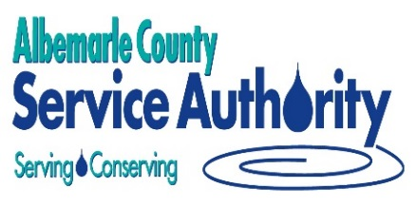
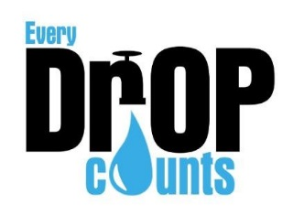
WATER CONSERVATION TIPS FOR BUSINESSES
Immediate and Long-term Practices for Implementation

